**Phase 2: Org Setup & Configuration - Step-by-Step Guide**

**Step 1: Salesforce Editions Selection**

**What to do:** Choose the right Salesforce edition for your Customer Success & Support Management CRM project

**Steps:**

1. Access your org (since this is a capstone project, you'll likely use a Developer Edition)
2. Go to **Setup** → **Company Information** to verify your current edition.
3. Note: For this project, **Developer Edition** is sufficient as it includes all necessary features for custom objects, workflows, and integrations.

**Step 2: Company Profile Setup**

**What to do:** Configure basic company information and settings

**Steps:**

1. Navigate to **Setup** → In Quick Find box, type **"Company Information"**
2. Click **Company Information**
3. Fill in the following details:
   * **Company Name:** "TechSuccess Solutions India Pvt Ltd."
   * **Primary Contact:** Ansh Ahuja.
   * **Company Address:** Madya Pradesh India,482001
   * **Phone:** NILL
   * **Fax:** NILL
   * **Website:** NILL
4. Set **Default Language:** English (India)
5. Set **Default Time Zone:** Indian Standard time zone(Asia/Kolkata)
6. Set **Default Currency:** English (India) - INR
7. Click **Save**

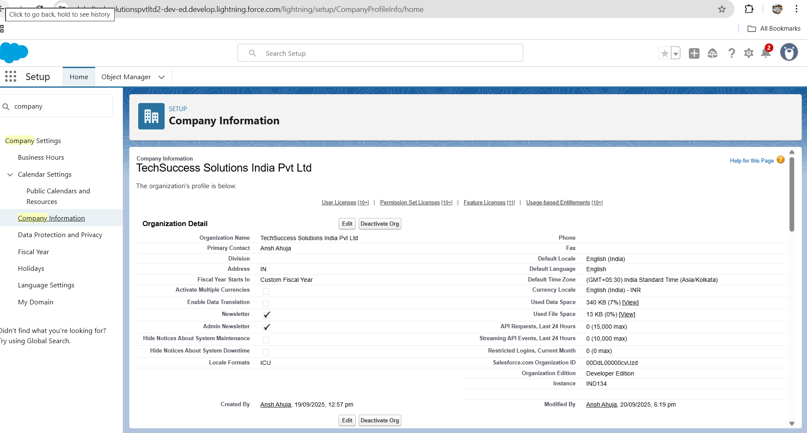

**Step 3: Business Hours & Holidays**

**What to do:** Configure when your customer success team is available

**Steps for Business Hours:**

1. Go to **Setup** → Quick Find → type **"Business Hours"**
2. Click **Business Hours**
3. Click **New Business Hours**
4. Enter details:
   * **Name:** "Customer Success Team Hours"
   * **Description:** "Working hours for customer success and support teams"
   * **Time Zone:** Select your time zone
   * **Active:** Check the box
5. Set working hours (for SaaS company):
   * **Monday:** 9:00 AM to 6:00 PM ✓
   * **Tuesday:** 8:00 AM to 6:00 PM ✓
   * **Wednesday:** 9:00 AM to 6:00 PM ✓
   * **Thursday:** 9:00 AM to 6:00 PM ✓
   * **Friday:** 9:00 AM to 6:00 PM ✓
   * **Saturday:** Leave blank (non-working day)
   * **Sunday:** Leave blank (non-working day)
6. Click **Save**

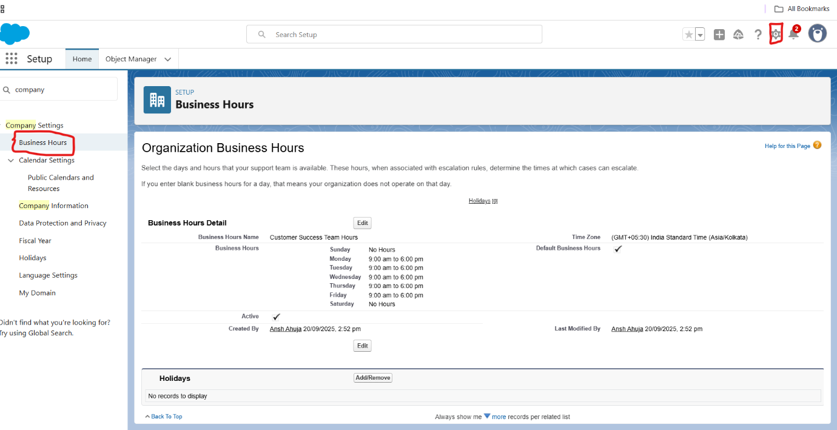

**Steps for Holidays:**

1. Stay in **Business Hours** section
2. Click **New Holiday**
3. Add holidays (examples):
   * **Name:** "Republic Day"
   * **Description:** "January 26th holiday"
   * **Date:** January 26, 2025
   * **All Day Event:** Check this box
   * **Business Hours:** Select "Customer Success Team Hours"
4. Repeat for other holidays (Independence Day, Gandhi Jayanti, Diwali, etc.)
5. Click **Save** for each holiday

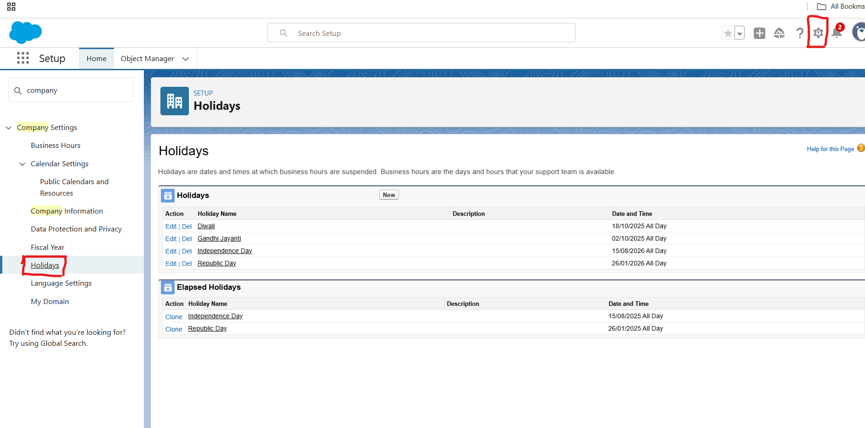

**Step 4: Fiscal Year Settings**

**What to do:** Set up your company's financial calendar

**Steps:**

1. Go to **Setup** → Quick Find → type **"Fiscal Year"**
2. Click **Fiscal Year**
3. Choose **Custom Fiscal Year**
4. Set **Fiscal Year Start Month:** April (or your company's fiscal year start)
5. **Fiscal Year Name Based On:** Starting Month
6. Click **Save**

**⚠️ Important Note:** Once you enable Custom Fiscal Year, you cannot disable it

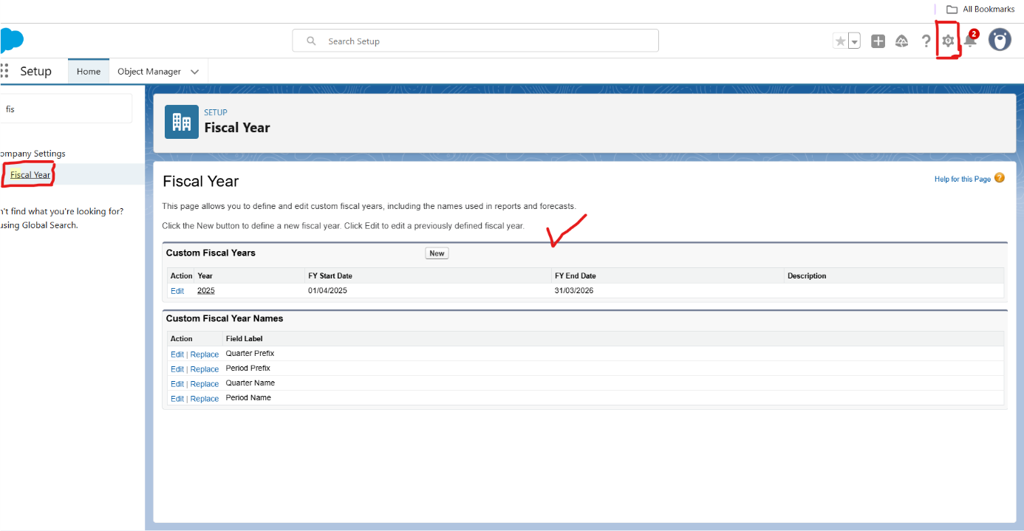

**Step 5: User Setup & Licenses**

**What to do:** Create users for your Customer Success CRM

**Steps:**

1. Go to **Setup** → **Users** → **Users**
2. Click **New User**
3. Create the following users (examples):

**User 1 - Customer Success Manager:**

* **First Name:** Sarah
* **Last Name:** Johnson
* **Alias:** SJohn
* **Email:** [sarah.johnson@techsuccess.com](mailto:sarah.johnson@techsuccess.com)
* **Username:** [sarah.johnson@techsuccess-dev.com](mailto:sarah.johnson@techsuccess-dev.com)
* **Nickname:** Sarah
* **Role:** (We'll set this in Step 7)
* **User License:** Salesforce Platform
* **Profile:** (We'll set this in Step 6)

**User 2 - Support Agent:**

* **First Name:** Mike
* **Last Name:** Chen
* **Alias:** MChen
* **Email:** [mike.chen@techsuccess.com](mailto:mike.chen@techsuccess.com)
* **Username:** [mike.chen@techsuccess-dev.com](mailto:mike.chen@techsuccess-dev.com)
* **User License:** Salesforce Platform
* **Profile:** (We'll set this in Step 6)

1. Click **Save** for each user

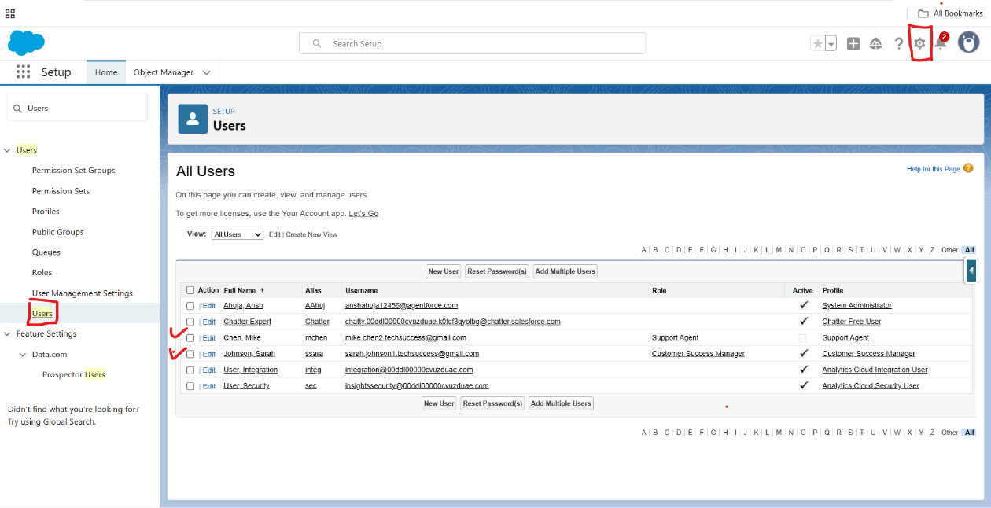

**Step 6: Profiles**

**What to do:** Create and configure user profiles

**Steps:**

1. Go to **Setup** → Quick Find → type **"Profiles"**
2. Click **Profiles**
3. Click **New Profile**

**Create Customer Success Manager Profile:**

1. **Clone From:** Standard User
2. **Profile Name:** "Customer Success Manager"
3. Click **Save**
4. Edit the profile settings:
   * **Administrative Permissions:** Give "View Setup and Configuration"
   * **General User Permissions:** Enable "API Enabled", "Edit Tasks", "Manage Cases"
   * **Standard Object Permissions:** Set Create, Read, Edit, Delete for Accounts, Contacts, Cases, Opportunities
5. Click **Save**.

**Create Support Agent Profile:**

1. **Clone From:** Standard User
2. **Profile Name:** "Support Agent"
3. Click **Save**
4. Edit permissions:
   * **Standard Object Permissions:** Focus on Cases (Create, Read, Edit), Accounts and Contacts (Read only)
5. Click **Save.**

**Step 7: Roles**

**What to do:** Set up role hierarchy

**Steps:**

1. Go to **Setup** → Quick Find → type **"Roles"**
2. Click **Roles**
3. Create role hierarchy:

**Top Level:**

* **Role Name:** "VP Customer Success"
* **Role Name as Displayed:** "VP Customer Success"

**Second Level (under VP):**

* **Role Name:** "Customer Success Manager"
* **This role reports to:** VP Customer Success

**Third Level (under CSM):**

* **Role Name:** "Support Agent"
* **This role reports to:** Customer Success Manager

1. Click **Save** for each role[s.](https://s2-labs.com/admin-tutorials/control-access-to-the-organization/)

**Step 8: Permission Sets**

**What to do:** Create flexible permission sets for additional access

**Steps:**

1. Go to **Setup** → Quick Find → type **"Permission Sets"**
2. Click **Permission Sets**
3. Click **New**

**Create Integration User Permission Set:**

1. **Label:** "API Integration Access"
2. **API Name:** "API_Integration_Access"
3. **Description:** "Permissions for integrating with external systems"
4. Click **Save**
5. Click **System Permissions**
6. Click **Edit**
7. Enable:
   * **API Enabled** ✓
   * **Apex REST Services** ✓
   * **View Setup and Configuration** ✓
8. Click **Save**

**Create Advanced Reporting Permission Set:**

1. **Label:** "Advanced Analytics Access"
2. **API Name:** "Advanced_Analytics_Access"
3. Enable permissions for:
   * **Run Reports** ✓
   * **Create and Customize Reports** ✓
   * **Create and Customize Dashboards** ✓
4. Click **Save**

**Step 9: OWD (Organization-Wide Defaults)**

**What to do:** Set default sharing settings for objects

**Steps:**

1. Go to **Setup** → Quick Find → type **"Sharing Settings"**
2. Click **Sharing Settings**
3. In **Organization-Wide Defaults** section, click **Edit**
4. Set the following defaults for your Customer Success CRM:
   * **Account:** Public Read/Write (customers need visibility across teams)
   * **Contact:** Controlled by Parent (follows Account sharing)
   * **Case:** Private (support cases should be restricted)
   * **Opportunity:** Private (sales opportunities need restricted access)
   * **Lead:** Private (leads should be assigned to specific users)
   * **Custom Objects:** Private (we'll create custom objects later)
5. Click **Save.**

**Step 10: Sharing Rules**

**What to do:** Create exceptions to OWD for specific groups

**Steps:**

1. Stay in **Sharing Settings** page
2. Scroll down to **Case Sharing Rules**
3. Click **New** in Case Sharing Rules section
4. Create **High Priority Case Sharing Rule:**
   * **Label:** "High Priority to All CS Team"
   * **Rule Name:** "High_Priority_to_All_CS_Team"
   * **Description:** "Share high priority cases with entire customer success team"
   * **Rule Type:** Based on criteria
   * **Criteria:** Priority equals "High"
   * **Share with:** Public Group (create "Customer Success Team" group first)
   * **Access Level:** Read/Write
5. Click **Save**

**Step 11: Login Access Policies**

**What to do:** Set up IP restrictions and security policies

**Steps for Profile IP Restrictions:**

1. Go to **Setup** → **Profiles**.
2. Select **Customer Success Manager** profile
3. Scroll to **Login IP Ranges** section
4. Click **New**
5. Set IP ranges (example):
   * **Start IP Address:** 49.36.27.1
   * **End IP Address:** 49.36.27.255
   * **Description:** "Office Network Range"
6. Click **Save**.

**Steps for Organization-Level Network Access:**

1. Go to **Setup** → Quick Find → type **"Network Access"**
2. Click **Network Access**
3. Click **New**
4. Add trusted IP ranges:
   * **Start IP Address:** 49.36.27.1
   * **End IP Address:** 49.36.27.255
5. Click **Save**

**Step 12: Dev Org Setup**

**What to do:** Prepare development environment

**Steps:**

1. Since I am using Developer Edition, your current org IS your dev org
2. Go to **Setup** → **Deploy** → **Deployment Settings**.
3. Enable **Allow Inbound Changes** (this allows you to receive deployments).
4. Click **Save**.

**Step 13: Sandbox Usage**

**For my project:** As I have use the developer edition org so I did not use the sandbox usage.

**Step 14: Deployment Basics**

**What to do:** Set up deployment connections

**Steps:**

1. Go to **Setup** → **Deployment Settings**
2. Note the **Deployment Connection** settings
3. For future deployments, you would:
   * Create **Outbound Change Sets** to deploy TO other orgs
   * Accept **Inbound Change Sets** FROM other orgs